CREATE DATABASE STUDENT_SOCIETY

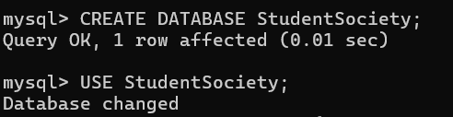

CREATE STUDENT TABLE



CREATE SOCIETY TABLE



CREATE ENROLLMENT TABLE

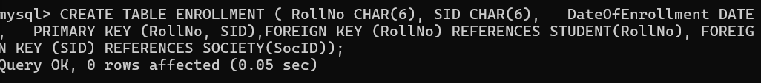

DESCRIBE STUDENT TABLE

INSERT VALUES INTO STUDENT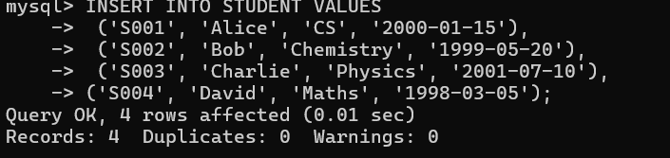

RETREIVE VALUES FROM STUDENT TABLE

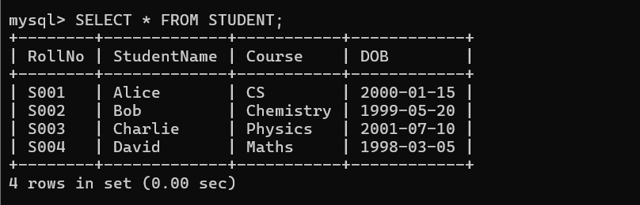

DESCRIBE SOCIETY TABLE

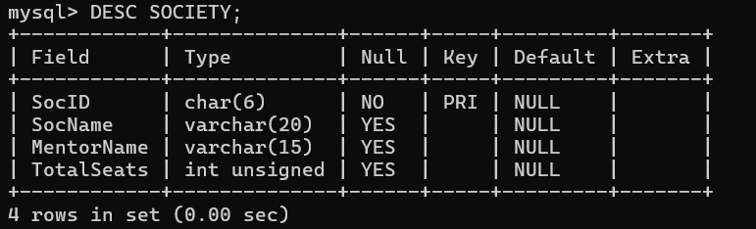

INSERT VALUES INTO SOCIETY

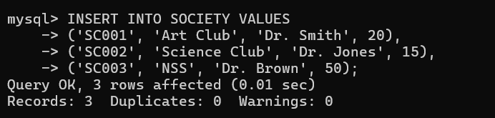

RETREIVE VALUES FROM SOCIETY TABLE

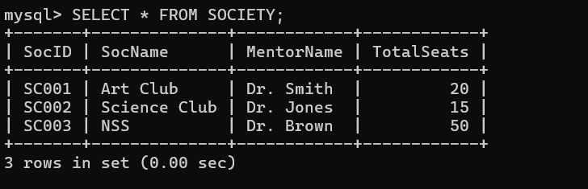

DESCRIBE ENROLLMENT TABLE

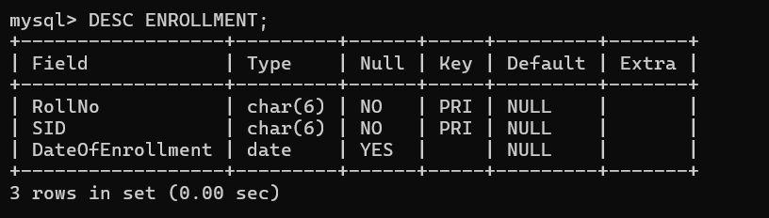

INSERT VALUES INTO ENROLLMENT

1. Retrieve names of students enrolled in any society.

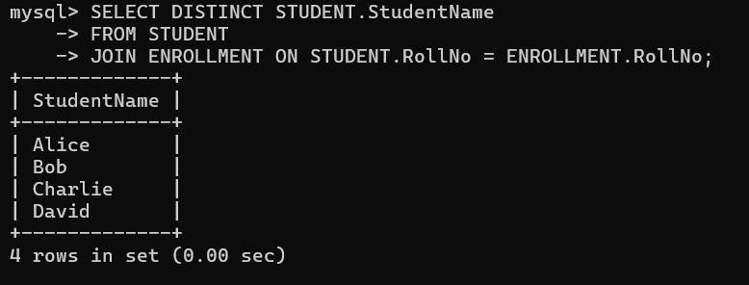

2. Retrieve all society names.

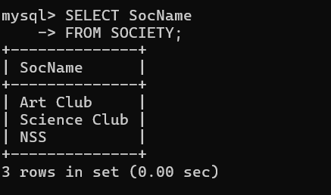

3. Retrieve students’ names starting with letter ‘A’

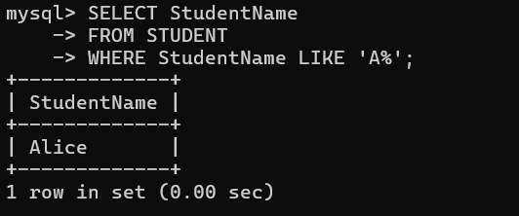

4.Retrieve students' details studying in courses ‘CS' or 'Chemistry':

5. Retrieve students' names whose roll number neither starts with 'X' nor 'Z' and ends with '9':

6. Find society details with more than N TotalSeats (N is user input):

7.Update society table for the mentor name of a specific society: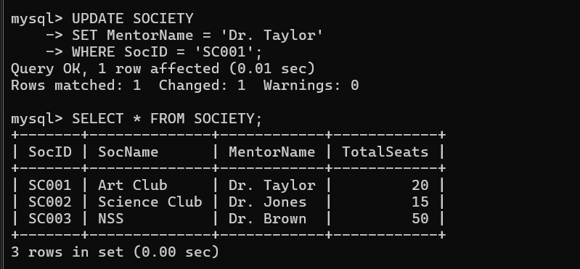

8. Find societies in which more than five students have enrolled:

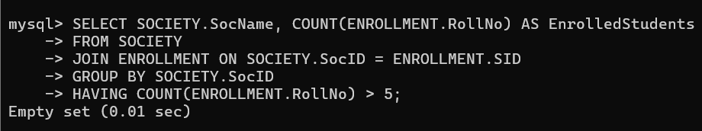

9. Find the name of the youngest student enrolled in society 'NSS':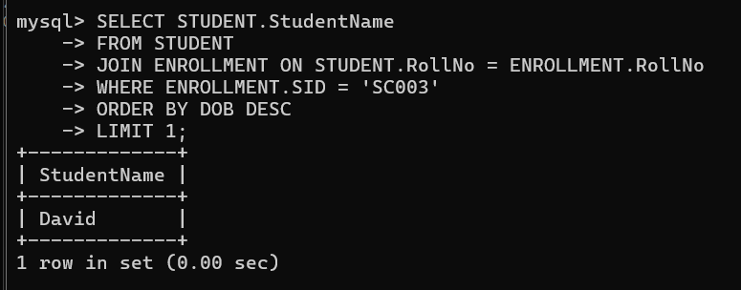

10. Find the name of the most popular society (on the basis of enrolled students):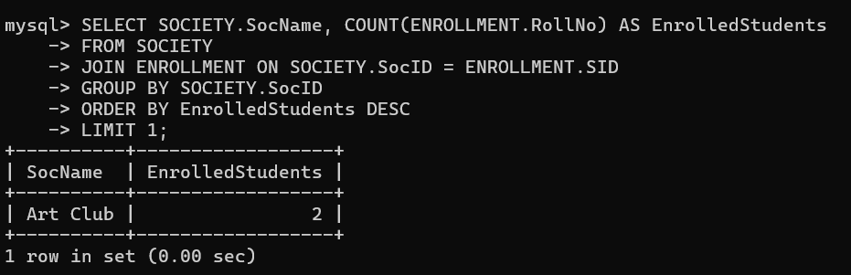

11. Find the name of two least popular societies (on the basis of enrolled students):

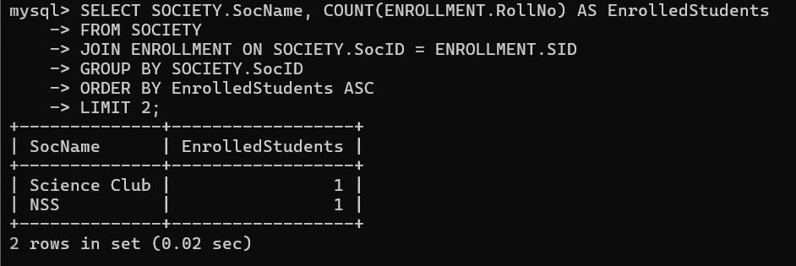

12. Find the students' names who are not enrolled in any society:

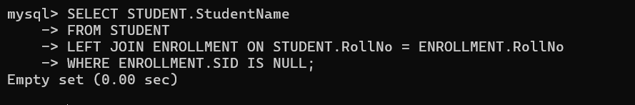14.

13.Find the students' names enrolled in at least two societies:

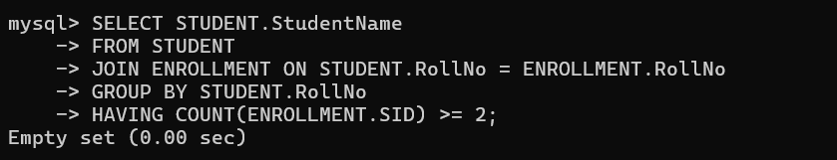

14. Find society names in which the maximum number of students are enrolled:

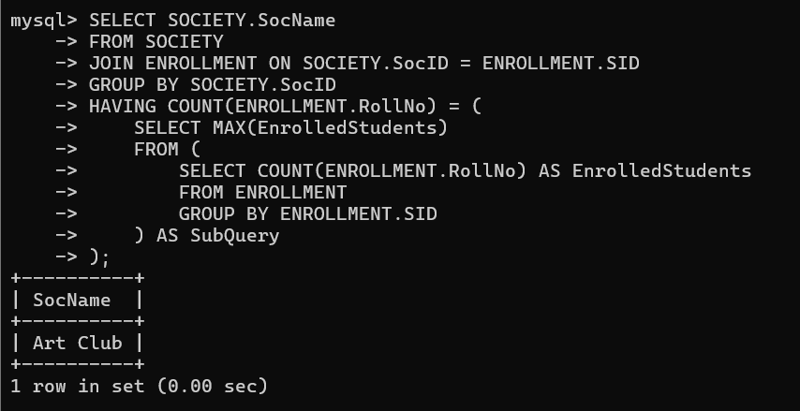

15. Find names of all students who are enrolled in any society and society names in which at least one student has enrolled:

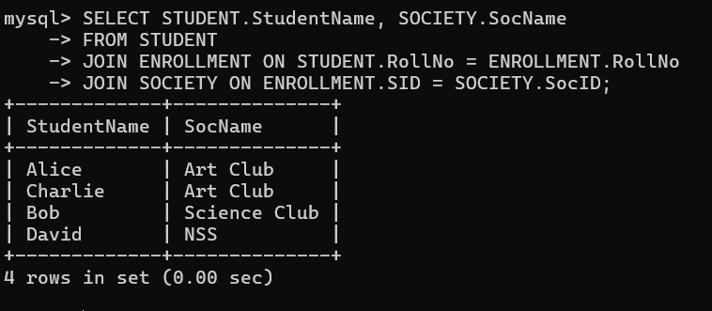

16. Find names of students who are enrolled in any of the three societies ‘Debating’, ‘Dancing’, and ‘Sashakt’:

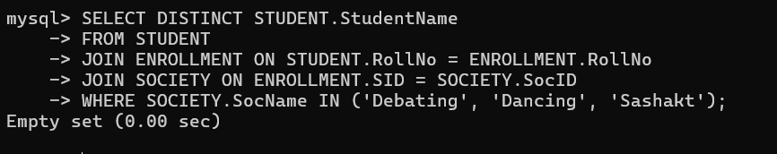

17. Find society names such that its mentor has a name with ‘Gupta’ in it:

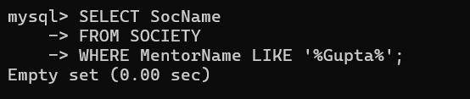

18. Add enrolment fees paid (‘yes’/’No’) field in the enrolment table.

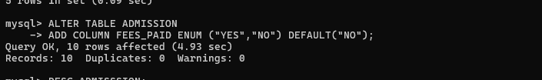

19. Display the vacant seats for each society:

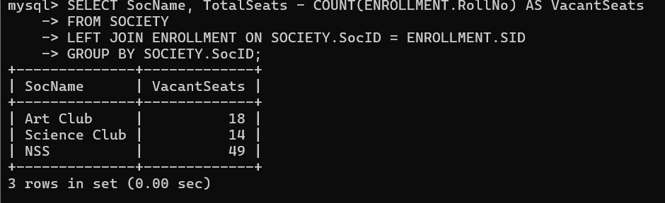

20. Increment Total Seats of each society by 10%:

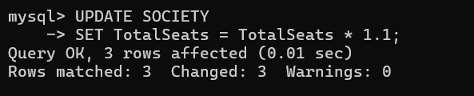

21. Add the enrollment fees paid (‘yes’/’no’) field in the enrollment table:

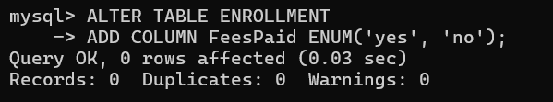

22. Update date of enrolment of society id ‘s1’ to ‘2018-01-15’, ‘s2’ to the current date and ‘s3’ to ‘2018-01-02’.

23. Create a view to track society names with the total number of students enrolled in it:

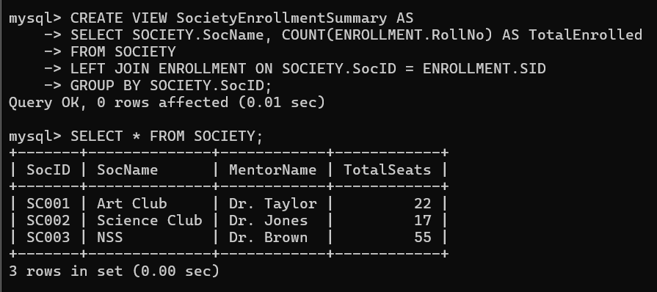

24. Find student names enrolled in all societies:

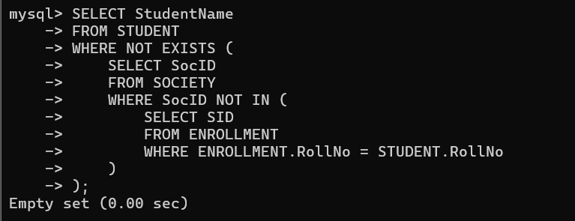

25. Count the number of societies with more than 5 students enrolled in it:

26. Add a Mobile Number column in the STUDENT table with a default value ‘9999999999’:

27. Find the total number of students whose age is > 20 years:

28. Find names of students who were born in 2001 and are enrolled in at least one society:

29. Count all societies whose name starts with ‘S’ and ends with ‘t’ and at least 5 students are enrolled in the society:

